Level 0 :

Level 0t o 1

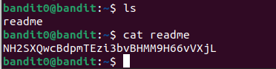

Level 1 to level 2:

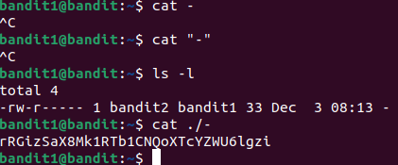

Level 2 to 3:

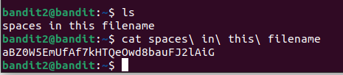

Level 3 to 4:

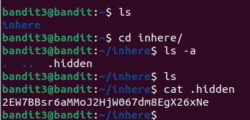

Level 4 to 5:

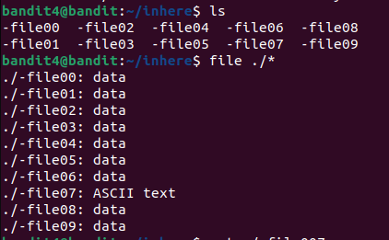

Level 5 to 6:

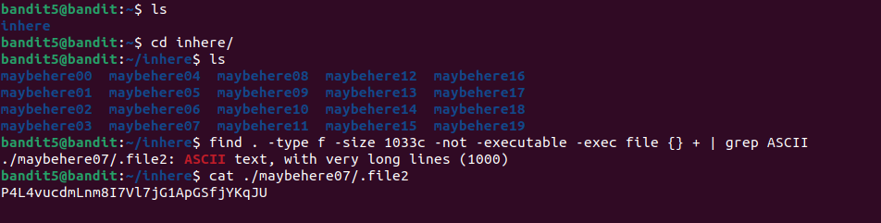

Level 6 to 7:

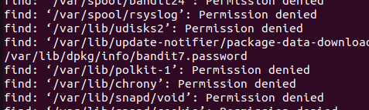



Level 7 to 8:

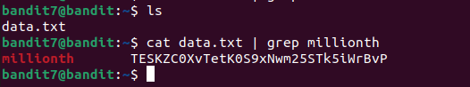

Level 8 to 9:

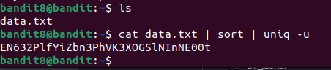

Level 9 to 10:

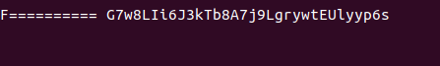

Level 10 to 11:



Level 11 to 12:

